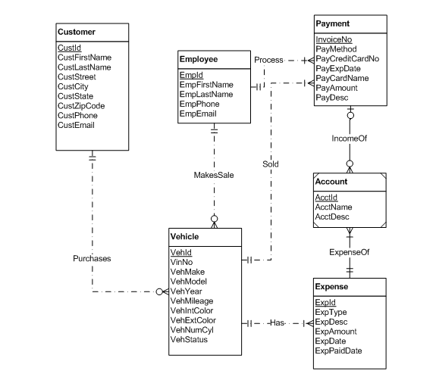

another attribute ‘Transmission type’should be added to vehicle entity.

Customer entity requires both primary phone and cell phone number attributes.

Purchases relationship should not have a mandatory customer as the narrative indicates vehicles may not be sold for a while.

Sales relationship should not have a mandatory employee because vehicles tend not to be sold instantly.

Income relationship should correspond to a single, mandatory account since the Account entity is a weak entity.